**EXPERIMENT - 3**

**AIM OF THE EXPERIMENT:**

To design and verify Non- Inverting Amplifier using multisim

**APPARATUS REQUIRED:**

PC loaded with multisim software

**THEORY:**

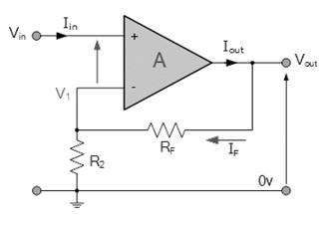**Non-inverting op-amp definition** is, when the output of an operational amplifier is in phase with an input signal then it is known as a non-inverting op-amp. In this amplifier, the input signal is applied to the +ve terminal of an operational amplifier. A non-inverting amplifier generates an amplified output signal that is in phase with the applied input signal.

**Vout = Vin + (Vin/R1)*R2**

non inverting op-amp gain , **Av = Vout/Vin = 1+ (R2/R1)**

**VERIFICATION:**

Circuit Diagram

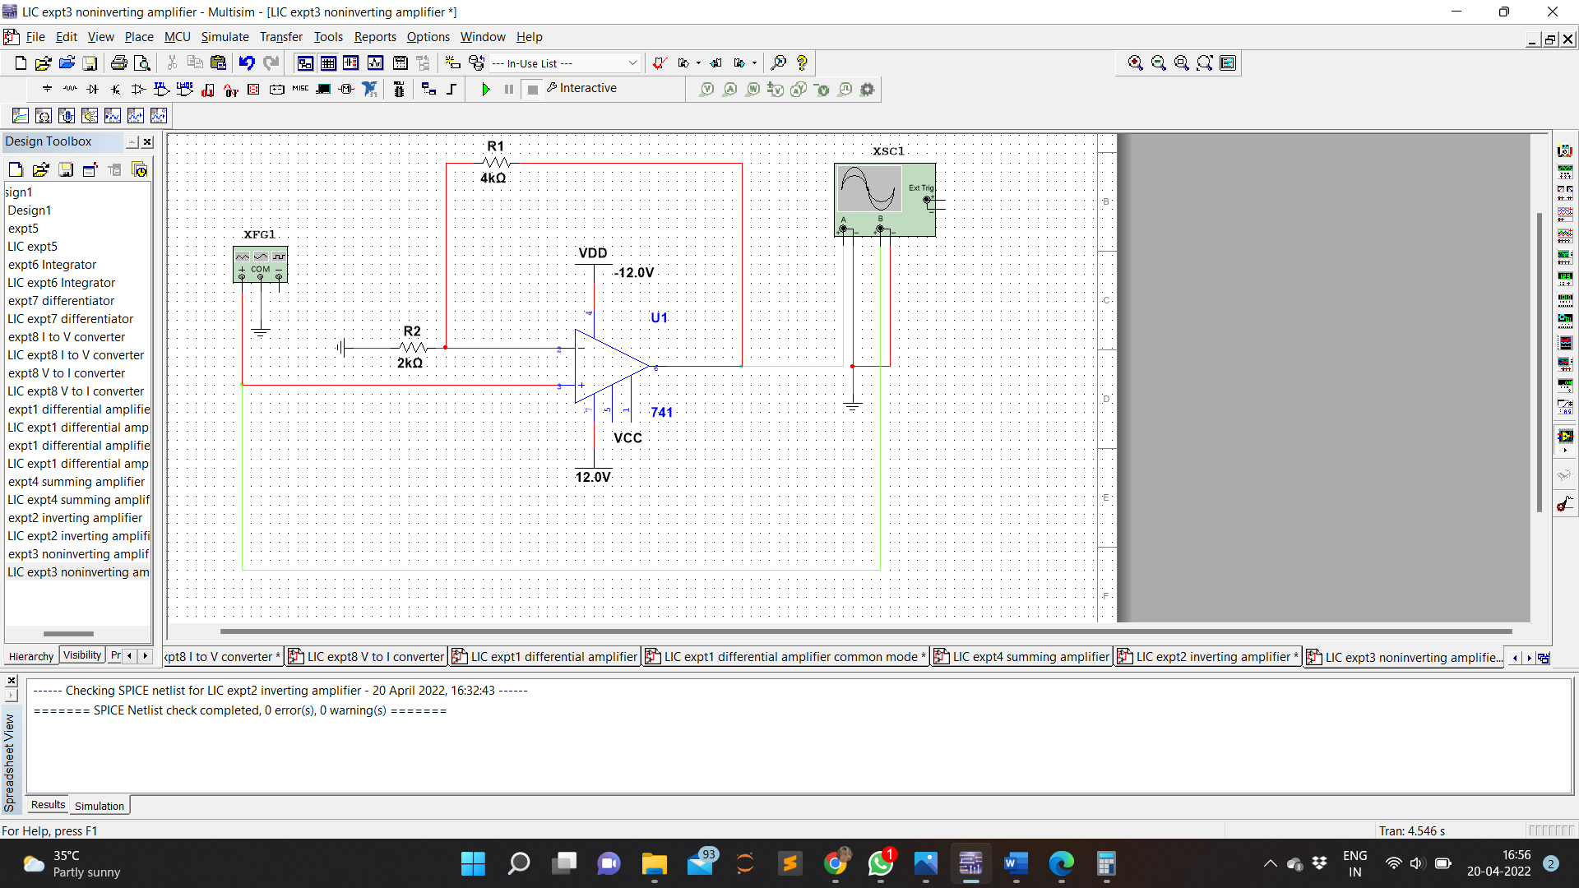

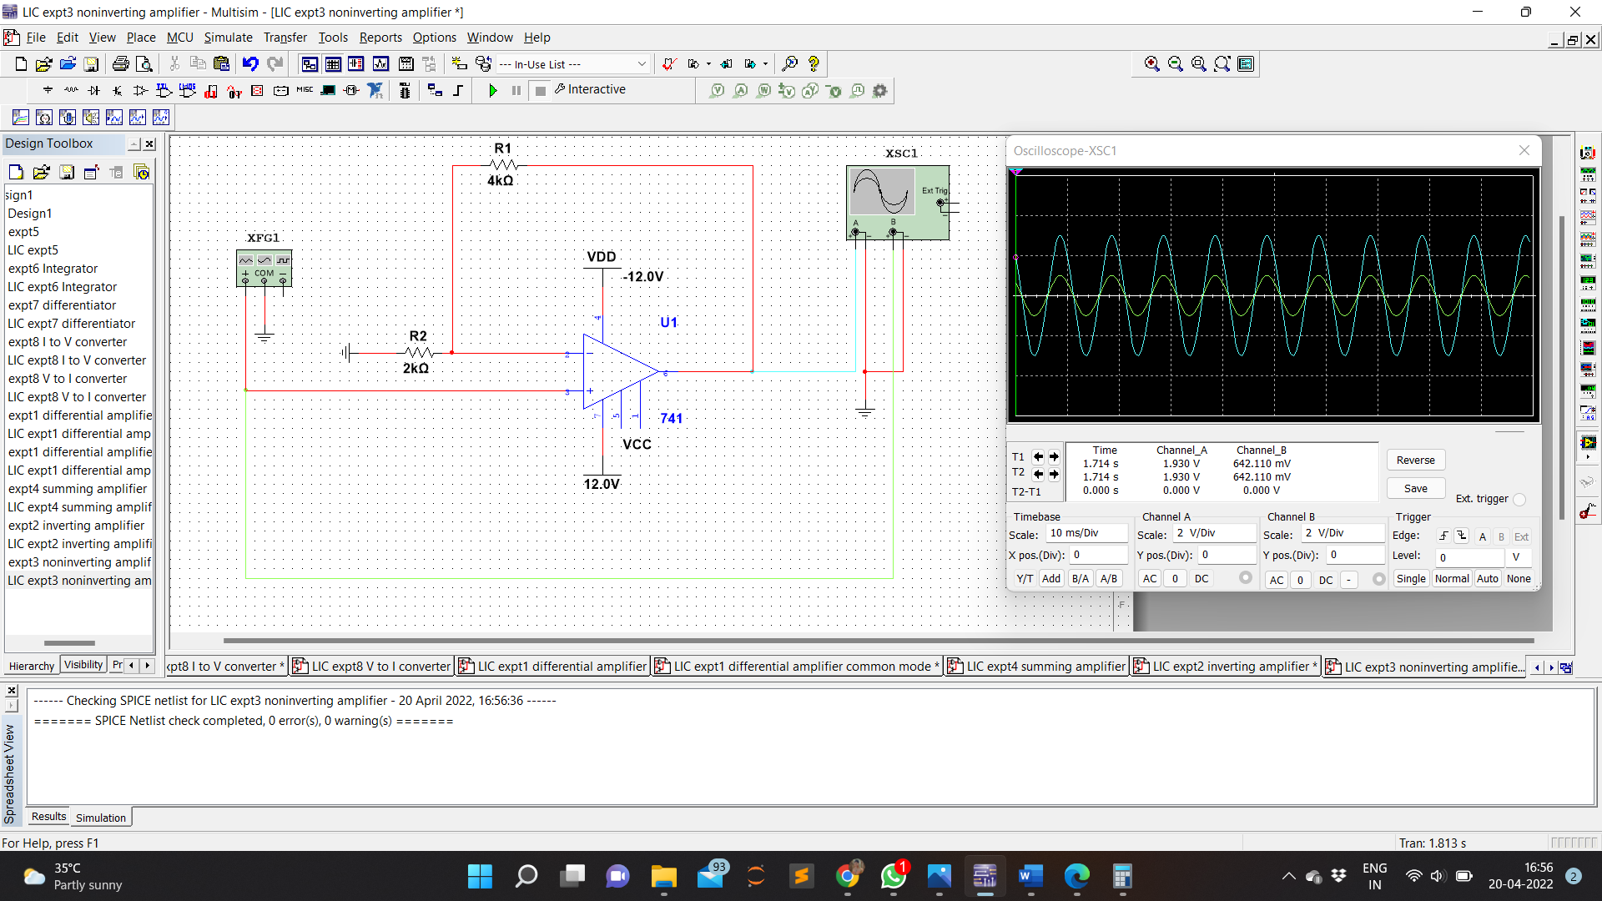Waveform

Calculation

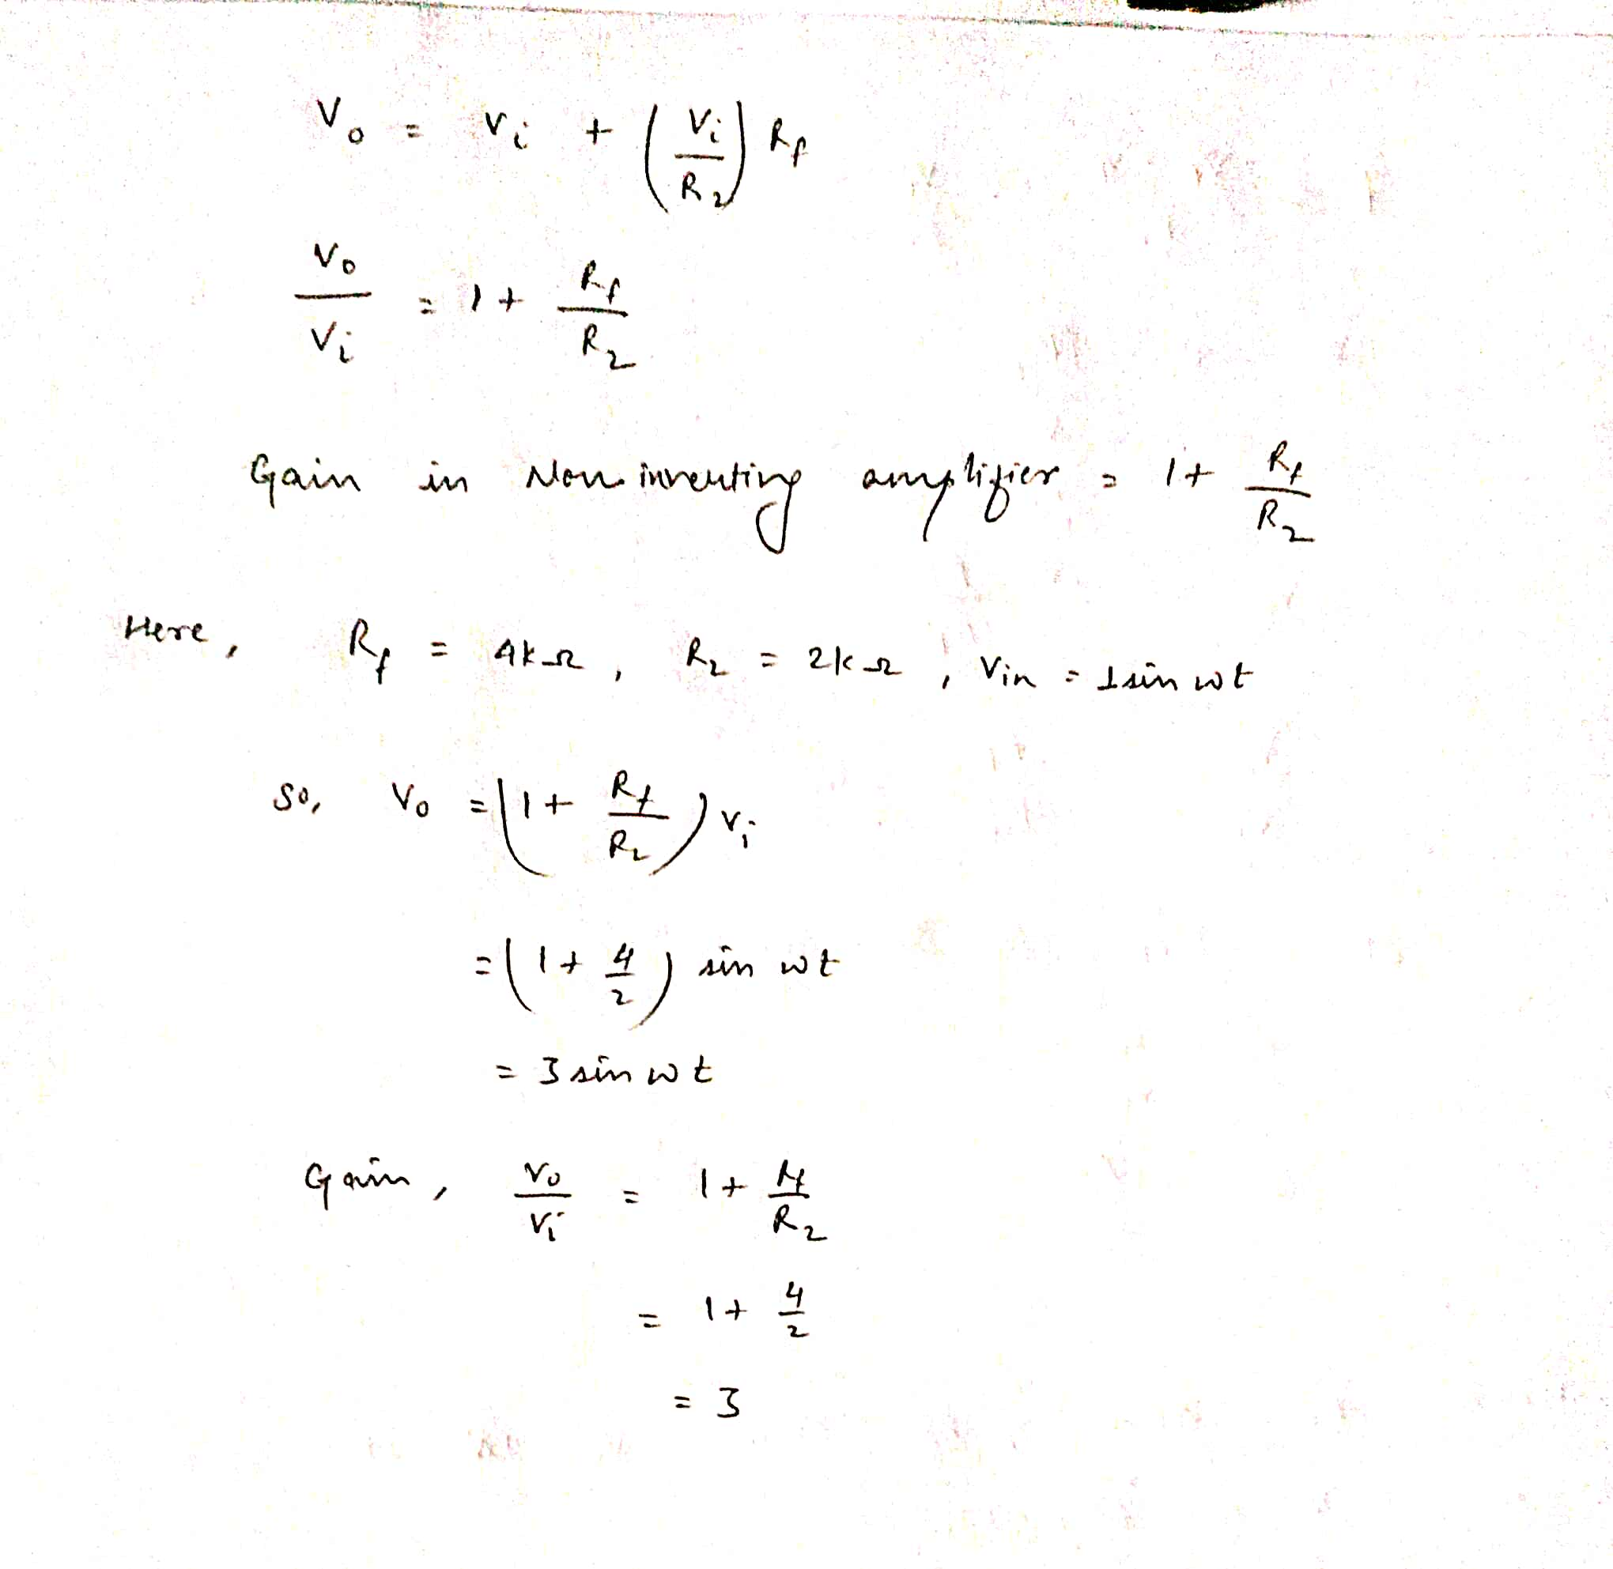

**RESULT:**

Non-Inverting operational amplifier was designed using multisim , simulated and verified